COMPUTER NETWORKING

Student name: Son Cao
Student number: 570135

assignment week 1: protocol analysis
Commands to open blobmac
Ns localhost 5107
- HELP – List all commands
- RECV – Receives concert tickets
- STAT – Lists all selected tickets
- LIST – Lists all possible concerts
- SLCT – Selects concert
- AMNT – Selects amount of tickets
- RSET – Clears concerts and the corresponding tickets
- EXIT – Closes program
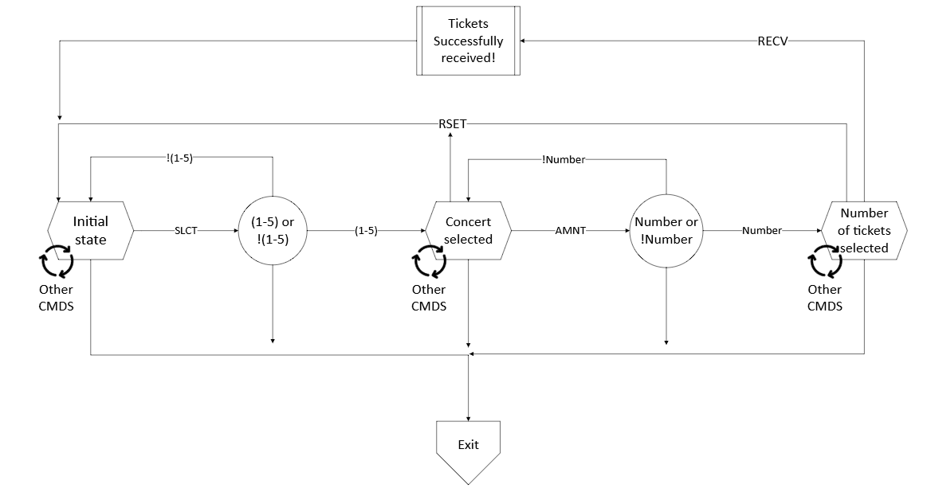
assignment week 2 & 3: Wireshark

How did the DNS lookup find the web address?
  - My computer sent a DNS query to the configured DNS server (e.g., Saxion's DNS server or my home router).
  - The DNS server resolved the domain name neverssl.com to its corresponding IP address (34.223.124.45).
  - The resolved IP address was returned to my computer, allowing it to establish a connection to the web server.
How long did it take to find and establish the connection and download the webpage + image(s)?
The total time was approximately 200-300 milliseconds:
  - DNS lookup: ~50 ms
  - TCP connection establishment (3-way handshake): ~100 ms
  - HTTP request and response (including webpage and images): ~100-150 ms
Approximately how many TCP packets, IP packets, and Ethernet frames were used? What were the average sizes?
  - TCP packets: ~20-30 packets (average size: ~500-1500 bytes)
  - IP packets: ~20-30 packets (average size: ~500-1500 bytes)
  - Ethernet frames: ~20-30 frames (average size: ~500-1500 bytes)
I determined this by filtering the Wireshark capture for TCP, IP, and Ethernet traffic and using the Statistics tool to calculate the average sizes.
Background Network Traffic
I started a Wireshark capture while running my daily applications (Outlook, Spotify, OneDrive, WhatsApp, Discord, Browser, etc.) and observed the following types of network traffic:
- DNS queries: Resolving domain names for various applications.
- HTTP/HTTPS traffic: Web browsing, API calls, and updates.
- TCP connections: Establishing and maintaining connections for applications like Outlook and Discord.
- UDP traffic: Used by Spotify for streaming and by Discord for voice chat.
- ARP requests: Resolving MAC addresses for devices on the local network.
- ICMP packets: Ping requests and responses for network diagnostics.
- Background OS traffic: Windows Update checks, NTP (time synchronization), and other system-related communications.
DHCP in Saxion vs. Home Network
- Saxion Network:
  - My device sends a DHCP Discover message broadcast to the network.
  - The Saxion DHCP server responds with a DHCP Offer, providing an available IP address.
  - My device sends a DHCP Request to confirm the offered IP address.
  - The DHCP server sends a DHCP Acknowledgment, finalizing the IP assignment.
  - The subnet mask provided by Saxion is typically 255.255.252.0
which defines the range of IP addresses available in the subnet.
- Home Network:
  - My device sends a DHCP Discover message to the home router.
  - The router responds with a DHCP Offer, providing an IP address from the home network's range
  - My device sends a DHCP Request to confirm the IP address.
  - The router sends a DHCP Acknowledgment, finalizing the assignment.
  - The subnet mask at home is 255.255.240.0, which allows for 240 devices in the subnet.
- Function of a Subnet Mask:
The subnet mask defines the network and host portions of an IP address. It helps devices determine whether a destination IP address is within the same local network or requires routing through a gateway.

assignment week 4 & 5: TCP client & server
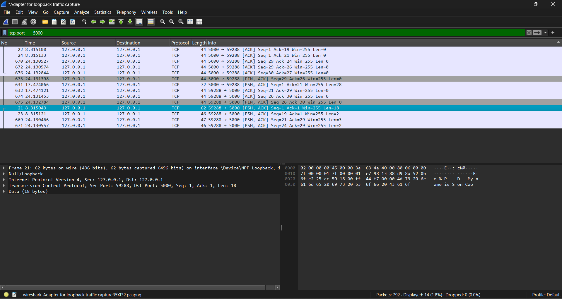
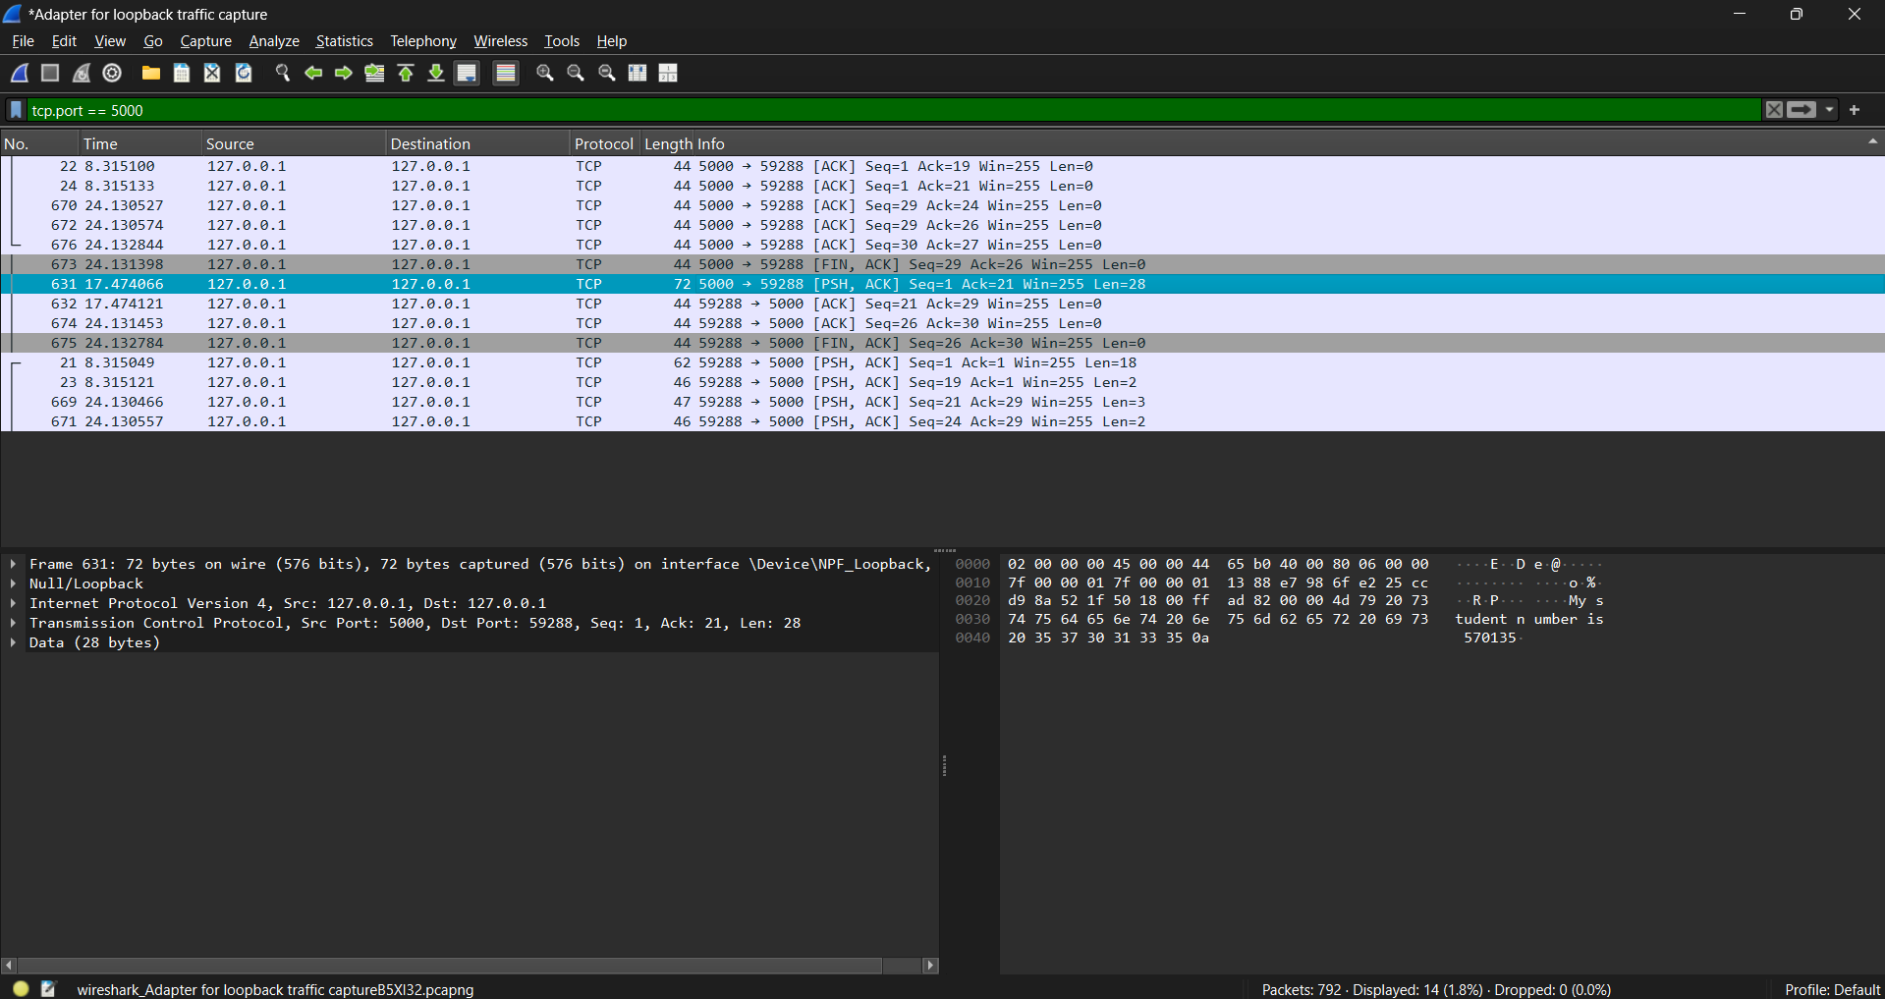

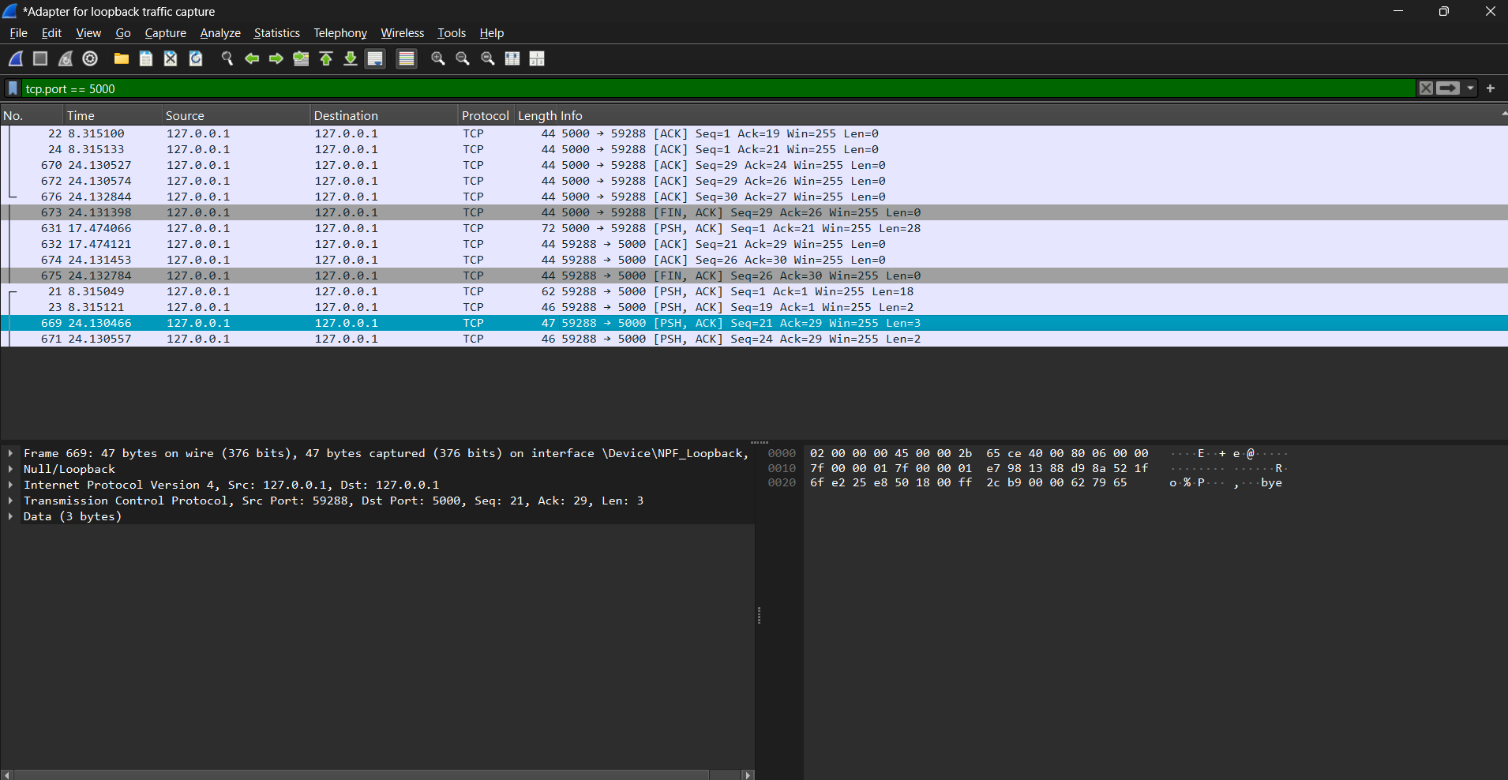
assignment week 6 & 7: pi pico networking
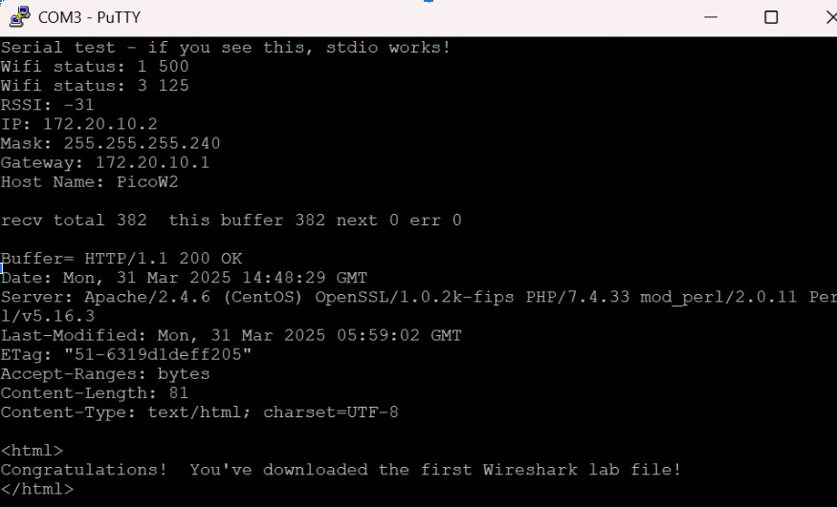
For this assignment, I successfully set up WiFi connectivity on my Raspberry Pi Pico W and retrieved a webpage from a remote server.
Setup Process:
- Downloaded and extracted the provided pico-wifi-example.zip files
- Modified credentials.h with my WiFi network details (SSID and password)
- Set up the project structure with the necessary CMake configuration
- Built and flashed the program to my Pico W
Challenges Faced:
- Initially had trouble with the Pico not connecting - realized I needed to update the SDK and firmware
- First attempt failed because I hadn't properly configured the PICO_BOARD variable in CMake

